Diet and Exercise in Pregnancy

Eating well when you're pregnant

A healthy diet is an important part of a healthy lifestyle at any time, but is especially vital if you're pregnant or planning a pregnancy. Eating healthily during pregnancy will help your baby to develop and grow, and will keep you fit and well.¹

Diet during Pregnancy: Food Groups ²

Fruits and Vegetables

- Fruits and vegetables contain many important nutrients for pregnancy especially, Vitamin C and Folic Acid.
- Pregnant women need at least 70 mg of Vitamin C daily, which is contained in fruits such as oranges, grapefruits, and vegetables such as cauliflower, tomatoes.
- A good source of folic acid can be found in dark green leafy vegetables (other sources of folic acid include legumes [beans (phaliyan), Peas (matar), Peanuts (mungaphali)]).
- You should have at least 2-4 servings of fruit (e.g., orange, apple, banana) and 4 or more servings of vegetables daily.

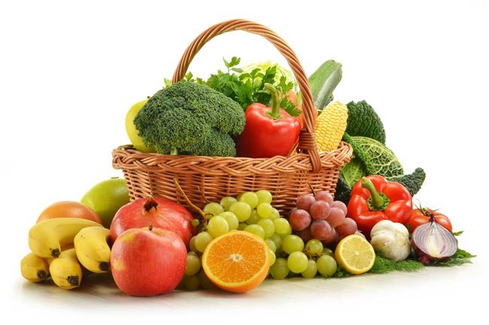

Breads and Grains
- The body’s main source of energy for pregnancy comes from the essential carbohydrates found in roti and bajra, jawar, rice.
- Whole grain and enriched products provide important nutrients such as iron, Vitamin B complex, fiber and some protein.
- Depending on your weight and dietary needs, you should consume anywhere between 6-11 servings (150-275 g) of roti/bajra/jawar/rice/grains daily.

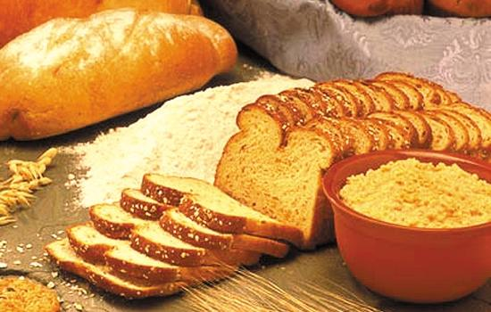

Protein
- Meat, chicken, fish, eggs, paneer, soya and green leafy vegetables (like methi and palak), beans contain the protein.
  - Your developing baby needs plenty of protein, especially in the second and third months. (or from 4th month onwards)
  - Iron helps to carry oxygen to your growing baby, and also carries oxygen to your muscles to help avoid symptoms such as fatigue and weakness.
  - Vitamin B complex and iron needed in pregnancy.
- You should consume at least 3 servings of protein daily.

Dairy Products
- At least 1000 mg of calcium is needed daily to support a pregnancy.
- Calcium is essential for building strong teeth and bones, normal blood clotting, and muscle and nerve function.
- Since your developing baby requires a considerable amount of calcium, if you do not consume enough through your diet, your body will take calcium from your bones, (which can lead to future problems, such as osteoporosis).
- Good sources of calcium include milk, cheese, yogurt, cream soups and puddings.
- Some calcium is also found in green vegetables, seafood, beans and dried peas.
- You should consume at least 4 servings of dairy products daily.

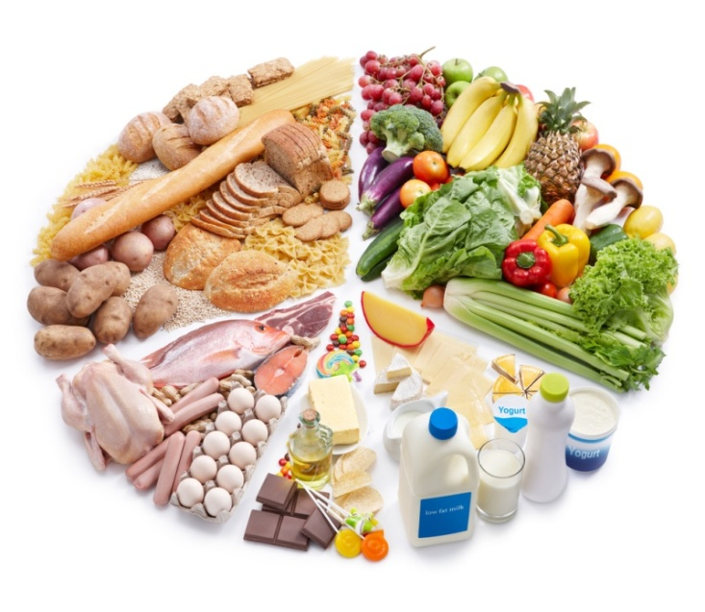

Exercise during Pregnancy

Maintaining a regular exercise routine throughout your pregnancy can help you stay healthy and feel your best. It can also improve your posture and decrease some common discomforts like backaches and fatigue. There is evidence that it may prevent gestational diabetes (diabetes that develops during pregnancy), relieve stress, and build more stamina needed for labor pains and delivery. ³

What Exercises Are Safe During Pregnancy? ³
Most exercises are safe to perform during pregnancy, as long as you exercise with caution and do not overdo it.
The safest and most productive activities are swimming, brisk walking, indoor stationary bicycling and low-impact aerobics (taught by a certified aerobics instructor). These activities carry little risk of injury, benefit your entire body, and can be continued until birth.
Please consult your doctor before starting to know the best exercise suitable to you.

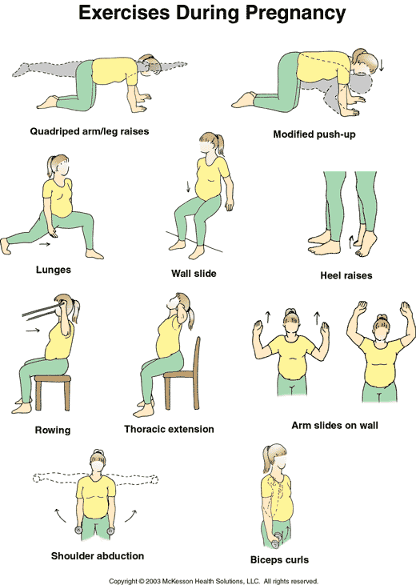

What Exercises Should Be Avoided During Pregnancy? ³
There are certain exercises and activities that can be harmful if performed during pregnancy. Avoid:
- Holding your breath during any activity
- Activities where falling is likely (such as horseback riding)
- Contact sports such as football, basketball and volleyball
- Any exercise that may cause even mild abdominal trauma, including activities that include jarring motions or rapid changes in direction
- Activities that require extensive jumping, hopping, skipping, bouncing or running
- Deep knee bends, full sit-ups, double leg raises and straight-leg toe touches
- Bouncing while stretching
- Exercises that require lying on your back or right side for more than three minutes. (especially after your third month of pregnancy)
- Waist twisting movements while standing
- Exercise in hot, humid weather

References

- http://www.nhs.uk/conditions/pregnancy-and-baby/pages/healthy-pregnancy-diet.aspx#close
- http://americanpregnancy.org/pregnancyhealth/diet-during-pregnancy/
- http://www.webmd.com/baby/exercise-during-pregnancy

