Female Reproduction
The female reproductive organs include: ¹
- Vagina (a muscular passage that connects the cervix with the external genital organs - one of which is a sensitive mound of tissue called the clitoris)
- Cervix (the lower part of the uterus that separates the body of the uterus from the vagina)
- Uterus (womb) - the uterus is a hollow, pear-shaped organ that is the home to a developing fetus. The uterus is divided into two parts: the cervix, which is the lower part that opens into the vagina, and the main body of the uterus, called the corpus (or body). The corpus can easily expand to hold a developing baby. A channel through the cervix allows sperm to enter and menstrual blood to exit.
- Ovaries (two glands that produce certain hormones and contain tissue sacs in which eggs develop)
- Fallopian tubes (two muscular channels that connect the ovaries with the uterus). Fingerlike projections called fimbriae (located at the opening of the fallopian tubes) sweep the egg released from an ovary into the tube

Cross-sectional View

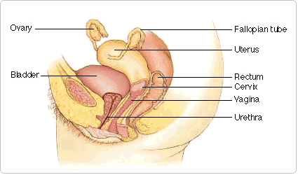

Front View

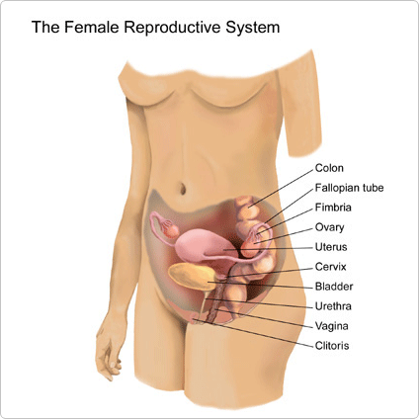

What does the female reproductive system do?

- Its main function is to give women the ability to produce ova to be fertilized, and the space and conditions to allow a fetus to develop.
- The female reproductive system also has the structures necessary to allow sperm from a man to meet the ova of a woman.
- The female reproductive system makes its own hormones that help to control a woman's monthly cycle.
- These hormones cause the development and release of ova so that they can be fertilized. This process is called ovulation.
- These hormones also prevent ovulation during pregnancy.²

References

- http://www.ama-assn.org//ama/pub/physician-resources/patient-education-materials/atlas-of-human-body/female-reproductive-system.page
- http://www.patient.co.uk/health/the-female-reproductive-system

