Infertility
For many couples, a wish is all it takes to start a family. For millions of others, fulfilling the dream to have a child can be a long and difficult journey. These struggling couples learn that fertility is just not fair. They spend time and money in their early years trying not to get pregnant, only to find out that when they are ready to have children, it might not be all that easy.
Infertility can be very stressful on individuals and on couples. For many couples, infertility is a crisis, and it causes feelings of guilt and anxiety. Many couples/individuals experience frustration, anger and sometimes even depression. Our advice to deal with these natural and normal feelings is to become educated about infertility, your options, and the various success rates associated with the differing treatments and clinics.
Whether you are just beginning your fertility journey or if you are well into treatment, it is critically important to be an educated patient. ¹
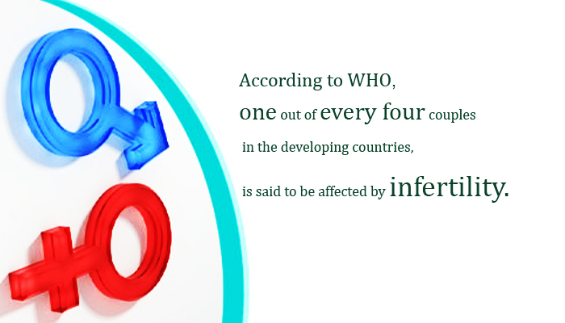

Definition

- Infertility is usually defined as one year of regular unprotected sex without a resulting pregnancy.
- Infertility affects up to 15 to 30% of couples at some time in their lives.
- A young (less than 30 years), healthy, fertile couple has about a 20 to 25% chance of conceiving a pregnancy in a single cycle. In other words, young couples having regular, unprotected sex have a one in five chance of conceiving each month.
- Approximately 40% of infertility is due to female factors such as blocked tubes or irregular or absent ovulation.
- Approximately 40% of infertility is due to male factors such as low sperm count or motility.
- About 15 to 20% of infertility is unexplained; that is, all tests are normal, and there is no obvious reason for not getting pregnant. ²

Common Causes of Infertility ³

  - Female Factors:
- Age
- Weight
- Behavioral Factors: Nutrition, exercise, smoking, drug, and alcohol intake can influence overall health and fertility.

Diseases associated with the female reproductive tract:
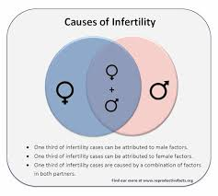
- Endometriosis (painful disorder in which tissue that normally lines the inside of your uterus — the endometrium — grows outside your uterus)
- Uterine fibroids (noncancerous growths of the uterus that often appear during childbearing years)
- Hypothalamic amenorrhea (condition in which menstruation stops for several months due to a problem involving the hypothalamus)
- Ovulatory disorders (conditions or irregularities that affect ovulation such as PCOS or polycystic ovarian syndrome, advancing age or reduced ovarian function)
- Pelvic Adhesive Disease (condition in which scar tissue binds adjacent organs to each other)
- Polycystic ovarian syndrome (condition in which a woman’s levels of the sex hormones estrogen and progesterone are out of balance)
- Premature ovarian failure (ovaries-which store and release eggs-stop working before age 40)
- Recurrent Miscarriage (spontaneous loss of pregnancy before the fetus reaches viability)
- Tubal disease (fallopian tubes are blocked or damaged)
- Unexplained infertility (cause remains unknown even after an infertility work-up)

  - Male Factors:
- No sperm count, less sperm count, reduced sperm motility, absence of one or both testes.
- Behavioral Factors such as: Nutrition, exercise, smoking, drug, and alcohol intake can influence overall health and fertility.
- Medications: Several medications, including those used to treat high blood pressure or ulcers, can influence a man's sperm count and libido and should be discussed with the prescribing primary care physician.

How can psychological treatment help me/us cope with infertility?

Mental health professionals with experience in infertility treatment can help a great deal. Their primary goal is to help individuals and couples learn how to cope with the physical and emotional changes associated with infertility, as well as with the medical treatments that can be painful and intrusive. For some, the focus may be on how to deal with a partner's response. For others, it may be on how to choose the right medical treatment or how to begin exploring other family building options. For still others, it may be on how to control stress, anxiety, or depression. By teaching patients problem- solving strategies in a supportive environment, mental health professionals help people work through their grief, fear, and other emotions so that they can find resolution of their infertility. A good therapist can help you sort out feelings, strengthen already present coping skills and develop new ones, and communicate with others more clearly. For many, the life crisis of infertility eventually proves to be an opportunity for life-enhancing personal growth.⁴

References
- http://webcache.googleusercontent.com/search?q=cache:http://www.azfertility.com/fertility-basics/
- http://www.usask.ca/medicine/obgyn/artus/docs/lifestyle_infertility.pdf
- http://www.azfertility.com/fertility-basics/causes-of-infertility/
- http://www.asrm.org/Psychological_FAQs/

